|  |  |
| --- | --- |
| NAME: _____________ | **Statistics and Probability** |
| Final Test Review | **DATE: Wednesday, May 31, 2017** |

**There is a lot of material on the test. I will divide the test in to sections and you will be able to skip a few sections.**

1. Cindy’s survey asked students at Deering if they thought they got enough sleep. Of 45 people she asked, 42% said they got enough sleep. Create a 95% confidence interval for the percent of all students who think they got enough sleep.
2. Cindy also asked students how many hours of sleep they got last night. The average of the 45 people was 7.2 hours with a standard deviation of 2.1 hours. Create a 95% confidence interval for the true average # of hours students sleep. Show all work and explain your answer in context.

My sock drawer has 6 black socks, 4 gray socks. If I take two out:

|  |  |
| --- | --- |
| P(both black) | P(neither is black): |
| P(match [same color], meaning both black or both gray) | |

35% of American adults are obese. Show work.

If three people are selected randomly:

|  |  |  |
| --- | --- | --- |
| P(all obese) | P(none are obese) | P(at least one is obese) |

If there are 5 people, find the probability exactly 3 are obese?

On the planet Ziron, parents always have 2 kids. The kids could be male, female, or ziron (an interesting combination of the other two).

1. Draw a tree diagram for all possibilities of 2 kids.
2. Answer the following questions based on picking on your tree diagram:
   1. P(not having a ziron on either birth):
   2. P(both the same type):

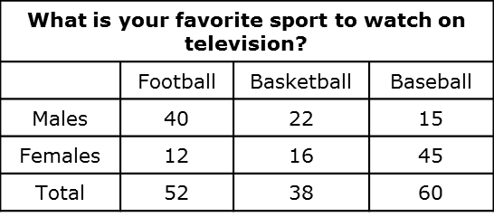

1. If a person is selected at random, find:
   1. P(male):
   2. P(fav sport to watch is basketball)
   3. P(male and favorite sport is basketball)
   4. P(male or favorite sport is basketball)

If the letters A, B, C, D, and E are to be used in a five-letter code, how many different codes are possible if repetitions are permitted?

If the letters A, B, C, D, and E are to be used in a five-letter code, how many different codes are possible if repetitions are not permitted?

If there are 8 people in the Olympic race and awards will be given to Gold,Silver, Bronze – how many ways could they be given out?

If a qualifying Olympic event, there are 8 people and the top 2 move on, how many different groups of 2 could move on?

The data below are how many wins the Warriors have gotten in the last bunch of years.

73,67,51,47,53

Find:

* Mean: ________
* Median: ________
* Mode: ________
* Range: ________
* *(6 points)*Standard Deviation (show all work on table below):

|  |  |  |
| --- | --- | --- |
|  |  |  |
|  |  |  |
|  |  |  |
|  |  |  |
|  |  |  |
|  |  |  |
|  |  |  |

Create a frequency distribution and then make a histogram.

|  |  |  |  |  |  |
| --- | --- | --- | --- | --- | --- |
| 12 | 16 | 20 | 23 | 25 | 30 |
| 12 | 16 | 20 | 23 | 27 | 34 |
| 13 | 18 | 21 | 24 | 29 | 34 |
| 14 | 18 | 21 | 25 | 29 | 35 |
| 15 | 19 | 23 | 25 | 30 | 37 |

Using the data on the miles per gallon, find the:

* Median:
* Quarter 1:
* The percentile of the car that gets 24 mpg.
* Find which car has a percentile of 60%
* What is the range?

Write three sentences about the following boxplot: It is the amount of rain in Vientam cities in May.

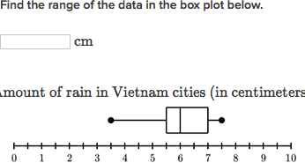

Show all work.

The average length of adult crocodiles in a swamp is 12 feet. If the lengths are normally distributed with a standard deviation of 1.8, find:

P(a crocodile is more than 11 feet long):



P(a crocodile is between 10 and 11 feet):



Sampling:

We want to find the avg amount adults sleep. Adults under 50 tend to sleep longer than adults over 50. In our adult population, adults under 50, make up 60% and adults over 50 are 40%. We want a sample of 50 adults. How would you conduct your sample

Design an experiment:

We want to see if a sleep bracelet that emits an electronic pulse will help people sleep better. We have 40 volunteers who are willing to try the device out. Of the 40 volunteers, 20 identify as good sleepers, 20 identify as poor sleepers.

1. What is the explanatory variable? What is the response variable?.
2. How are you going to do the experiment? Can it be blind/double blind?